

*Gesture Based UI Development Project*

*Multiplayer Checkers Game*

*Using Leap Motion and Cortana*

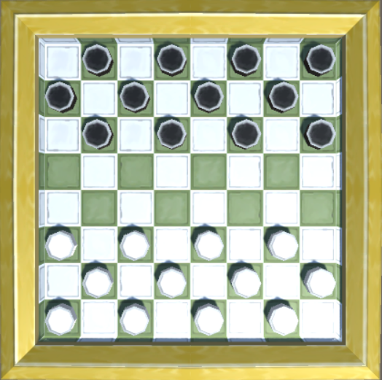

*Christopher Weir - G00309429*

*Dara Starr - G00209787*

Table of Contents

Team Members: 2

Github Link: 2

Project Idea: 2

Purpose of the application 2

Game Design 3

Problems Encountered 8

Gestures identified as appropriate for this application 9

Hardware used in creating the application 10

Architecture for the solution 10

Technologies 10

Architectural Diagram 11

Class Diagram 12

Conclusion 12

# Team Members:

Christopher Weir - G00309429

Dara Starr - G00209787

# Github Link:

<https://github.com/Chrissweir/Gesture-Based-Checkers-game>

# Project Idea:

For the Gesture based UI project we have decided to make a game of checkers (known as draughts). We plan to use the Leap Motion or Cortana for controlling each player’s move. It will be a multiplayer game allowing two players to connect using the hosts ip address which will let the players play from any location. The gestures for the leap will be a simple pinch, drag and drop to move the pieces. Cortana will be able to control the launching of the game and the navigation through the games UI. Touchscreen will also work with this game.

# Purpose of the application

The purpose of this application was to create a game using Unity that uses the Leap Motion device and Cortana to control the movement of the pieces in a game of checkers. Originally, we planned for this to be a multiplayer game in which one player could use Leap while the other used Cortana to play against each other across a local network.

Due to complications while developing this application we ended up with two versions of our project, one with both multiplayer and Leap incorporated, and the other a single player version which we had and still hope to incorporate Cortana. The problems encountered are explained [below](https://galwaymayoinstitute.sharepoint.com/sites/GestureBasedUIDevelopment/Shared%20Documents/Chris%20Weir%20Dara%20Starr.docx).

Game Design

Upon launching the application, the user is met with the main menu. From here the user can enter their name, choose to play hotseat (single player), connect to another users game, or host their own game.

The main menu is as follows:

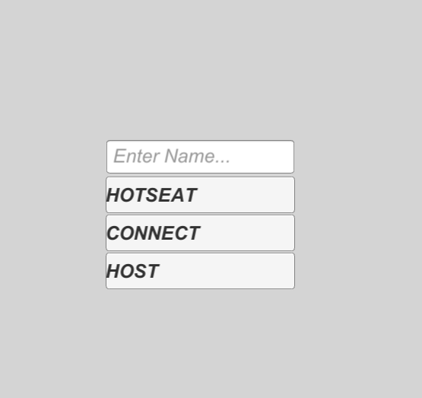

If the user clicks the hotseat button they will start a game by themselves:

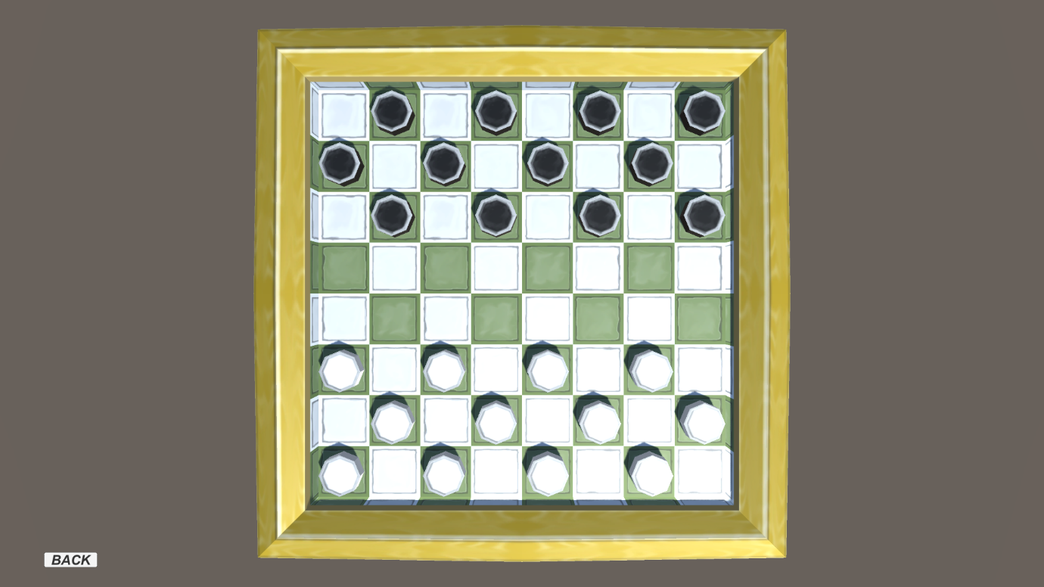

The user can play the game from here or click the back button on the bottom left to exit the current game.

If the user clicked the connect button they will be prompted with this screen:

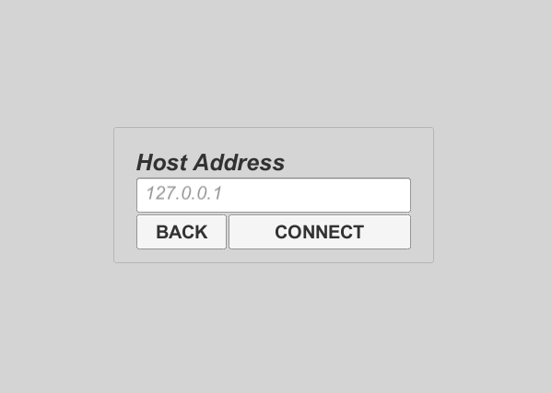

Here the user can enter the ip address of the user they wish to connect to or they can choose to return to the main menu by clicking the back button. The connection is run through port 2017. Once the ip address is entered the user clicks the connect button, this will attempt to establish a connect with the host, who must be currently hosting for a connection to be accepted. After the connection has been made both players will be directed to the game and they can begin to play.

When the user clicks on the host button on the main menu the will be shown the following screen:

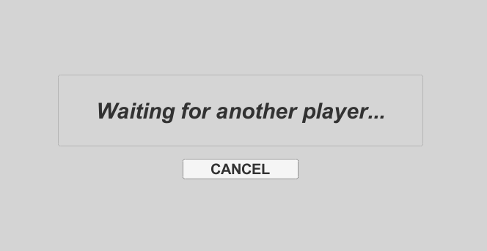

From here the user must wait for another player to connect to them. They can also click the cancel button to return to the main menu.

The general game logic was fully implemented for the checkers game:

Forced moves with highlighting:

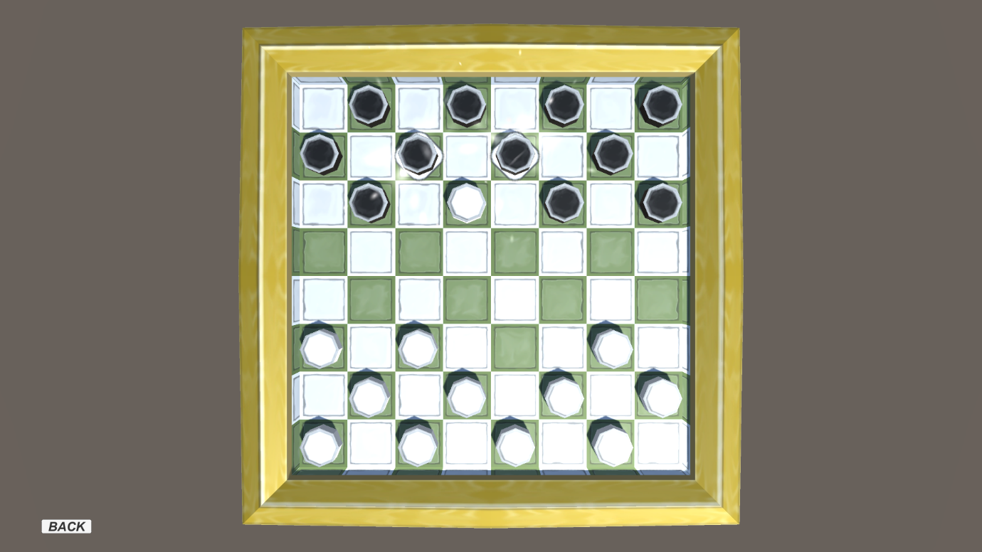

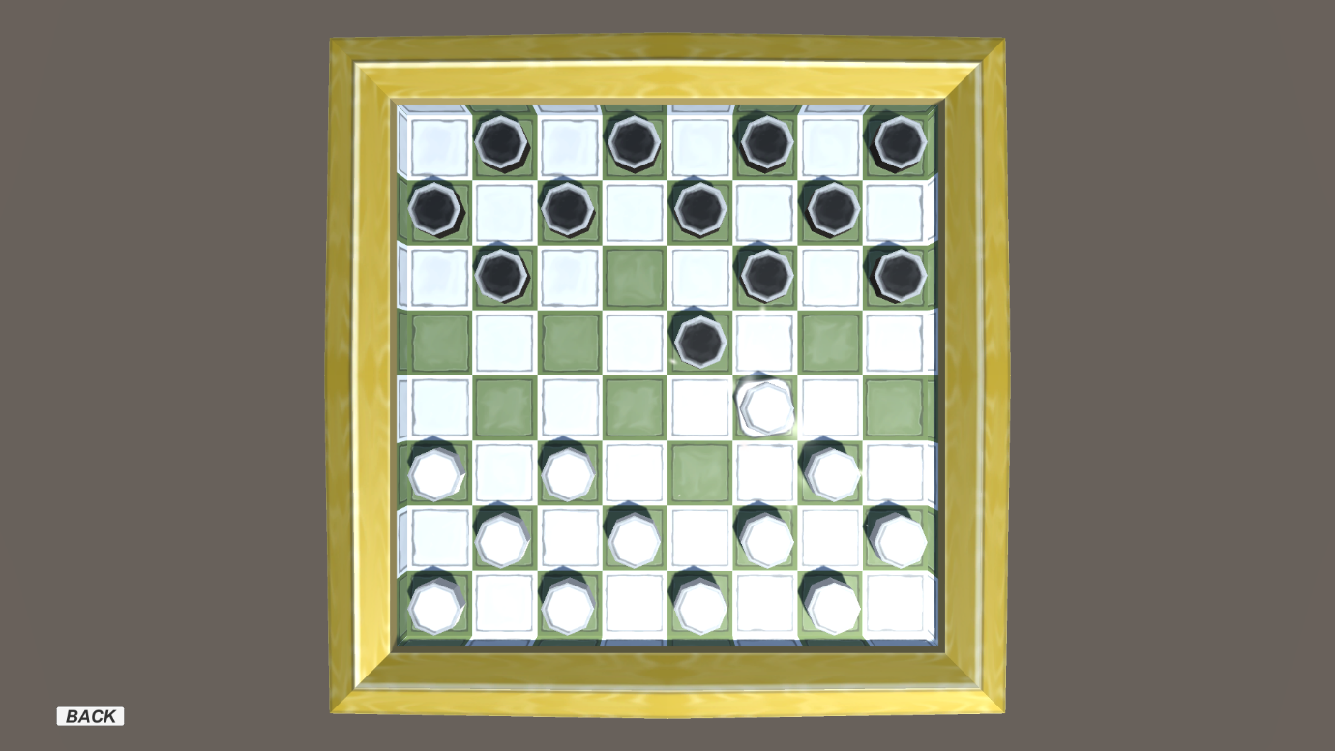

The game logic is set up using the forced piece house rules, in which if a player can take the opponents piece, they must.

The king piece:

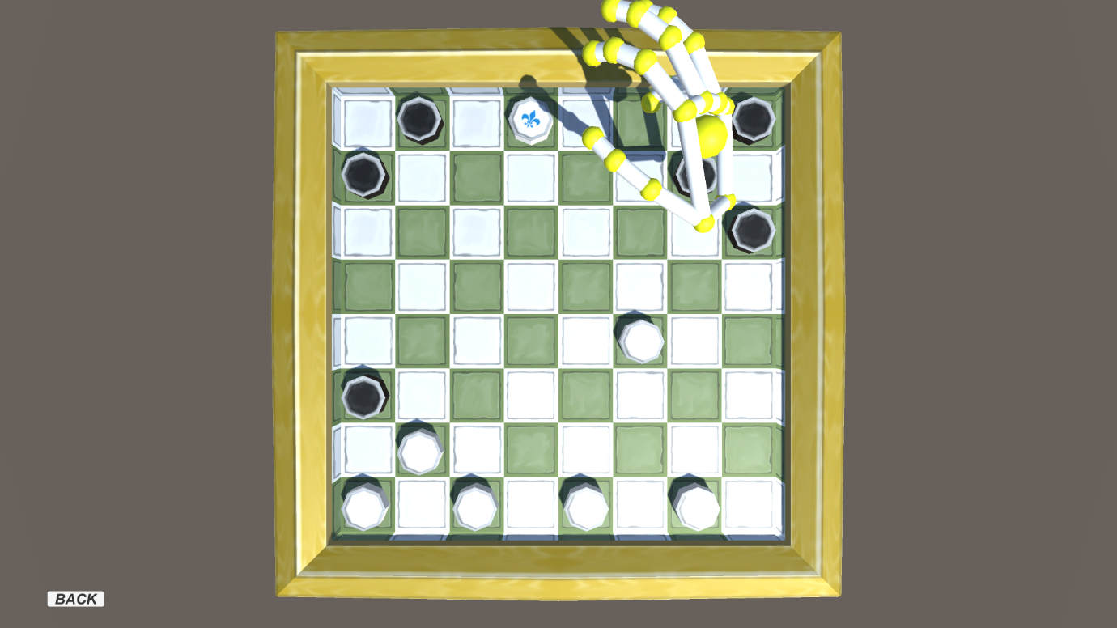

When a player wins a game, an alert is displayed and after 3 seconds the players are returned to the main menu.

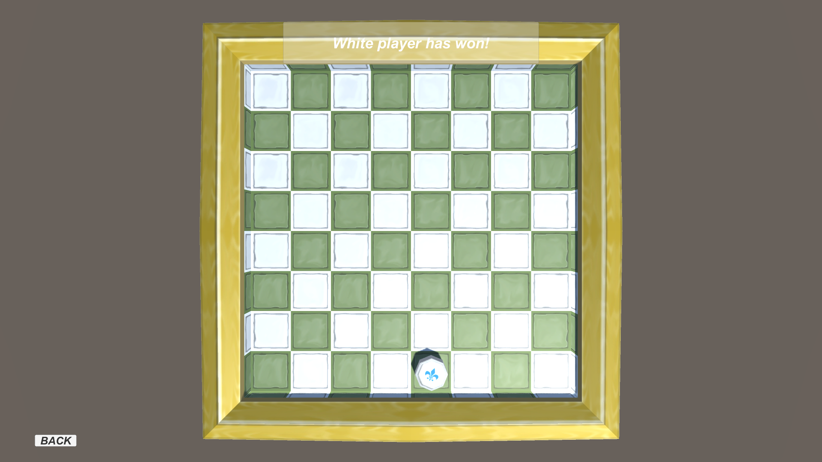

Problems Encountered

Unity Porting to Windows 10

The most substantial problem that we encountered in developing the Checkers game was after integrating the Leap Motion into the Unity project we wanted to port the project out to a Windows 10 project using Visual Studio 15. In the game itself we setup a two player function across two PC’s using TCP clients, TCP listeners, NetworkStreams, StreamWriter and StreamReaders from System.Net.Sockets. When trying to build the project in Unity the .Net version could not find the System.Net.Sockets namespace which caused a build error. After spending several days trying to fix this issue and external help from lecturers and field professionals we had to give up on it.

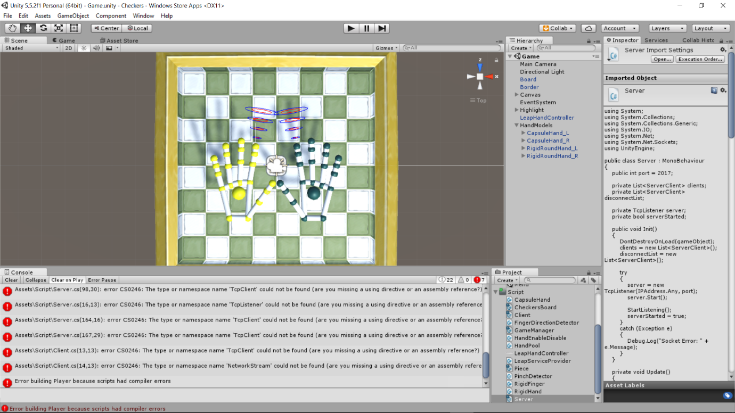

Cortana

We had planned to implement Cortana for the launching and setup of the game. Due to the issue explained above we could not use the full multiplayer and Leap Motion version as we could not open it in Visual Studio 15. Instead we decided to make a second project game without multiplayer and Leap just to incorporate Cortana. After getting the game ported to a Windows 10 application we started to add in Cortana functionality. Confident we had it correctly implemented we tried to use it to launch the game but it would not work. When trying to run the game on other machines in Visual Studio we encountered an error for an Assembly Interpreter which mapped the project back to the machine on which it was created hence not finding the correct file path.

# Gestures identified as appropriate for this application

Since this application is a checkers game, the main gesture is a pinch motion. The user pinches above the desired piece and holds the pinch, the user can then move the piece. This gesture makes the most sense as the user is controlling checker pieces, which when playing a real game of checkers, are moved by picking the piece up and moving physically moving it.

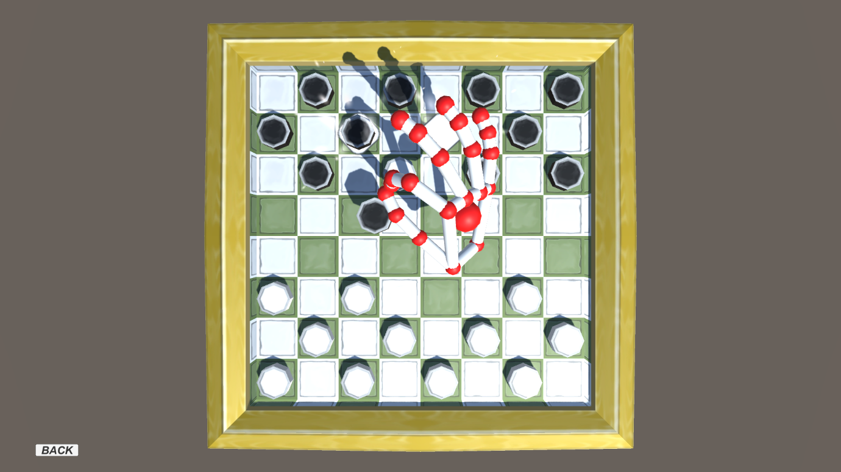

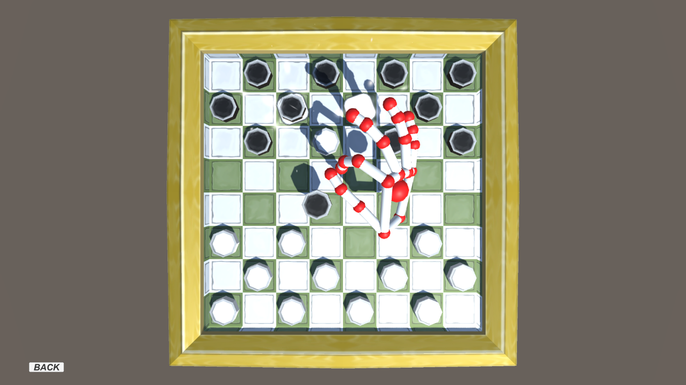

As we tried to implement Cortana during the development of this application we had created a set of commands to control the launching of the application and the selecting of each option from the main menu. Unfortunately, we were never able to test these gestures due to the problems we encountered. However, if Cortana had worked according to plan, we could have created more commands to control the movement of pieces based off the coordinates spoken by the user, which was our initial plan.

# Hardware used in creating the application

**Leap Motion** is a computer hardware sensor device that supports hand and finger motion as input but requires no hand contact or touching. It can also be used for hand tracking in virtual reality. The Leap Motion can be used either placed on a physical desktop facing upward or it can be mounted onto a virtual reality headset. It uses two monochromatic IR cameras and three infrared LEDs. Its optimal working range is approximately one meter. The smaller observation area and higher resolution of the device makes the product different from rivals like Microsoft's Kinect, which is better suited for whole body tracking.

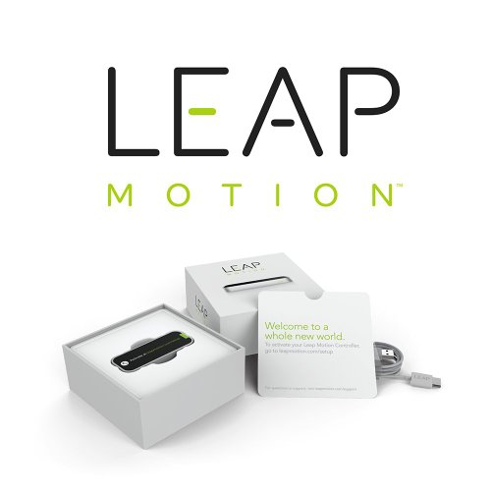

When planning this project, we decided to use the Leap Motion due to the checkers game idea, as it could mimic the natural movement of a hand to move the pieces.

# Architecture for the solution

Technologies

This chapter will discuss the various technologies used in completing this project.

* Leap Motion Controller
* Cortana (Not implemented)
* Touchscreen
* Visual Studio 2015
* Unity (Game Engine)
* Github (Source control)
* Unity Cloud Build Integration (Collaborative project creation on the cloud)

Architectural Diagram

The following image is a visual representation of the project layout.



During the development of the application we used Unity Cloud Services to help provide source control when working on the project at the same time.

Class Diagram

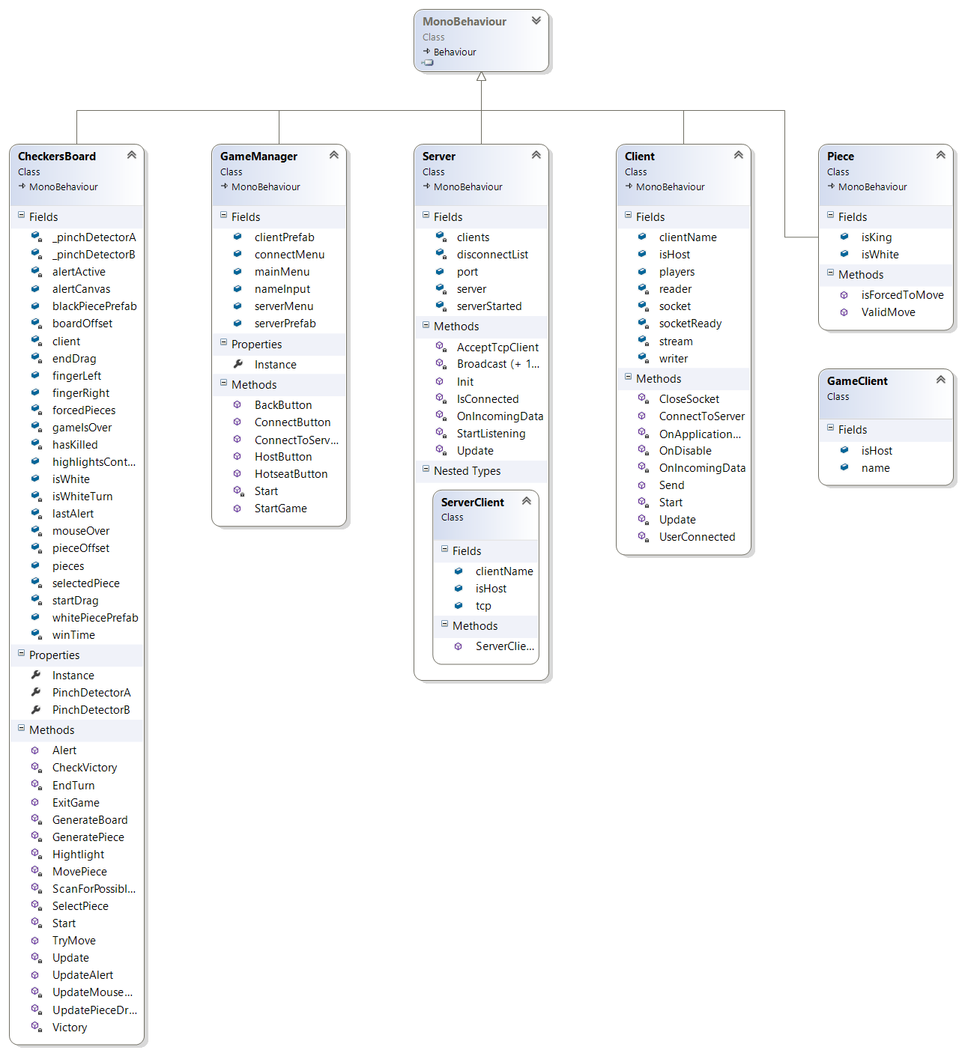

# Conclusion

After working on this project for the past few weeks we have learned the capabilities and the downfalls of using the technologies which we chosen. We firstly found out after completing the game and incorporating multiplayer and controlling the piece movement with Leap that the .Net versions are not compatible from Unity to a Universal Windows Phone application. Also, trying to incorporate Cortana in a second project proved difficult not because of implementing it incorrectly but our machines not being configured right to run our code. A lot of our time spent doing this project was researching solutions for problems encountered. What we have learned is that even the best laid plans which in theory should work might not be possible with the technologies we were using. We even went as far as getting professional opinion on our errors with no success. This project has really thought us as developers that not everything will work out exactly as planned and sometimes somethings are just impossible.